
USER INTERFACE DESIGN
23CSE113
WEB APPLICATION REPORT

SUBMITTED BY
NAME | P.KUSUMA
ROLL.NO | AV.SC.U4CSE25045
YEAR/SEM/SECTION | 1ST YEAR/SEM-2/CSE-A

SUBMITTED TO | DR RAJ KUMAR BATCHU
DESIGNATION | ASST.PROFESSOR(Sl.Grade)
DEPARTMENT | SCHOOL OF COMPUTING

INTRODUCTION
The Pet Finder Website is designed to assist users in finding suitable pets for adoption and learning more about pet ownership. The website provides organized information about dogs, cats, and other animals along with adoption resources and educational articles. The platform offers an attractive user interface and responsive design to ensure accessibility across different devices.

SOFTWARE AND TOOLS USED
Technology | Purpose
HTML5 | Structure of web pages
CSS3 | Styling and responsive design
JavaScript | Dynamic functionality
Font Awesome | Icons
Google Fonts | Typography
VS Code | Development Environment
GitHub | Version Control

WEBSITE ARCHITECTURE
User
↓
Web Browser
↓
HTML Pages
↓
CSS Styling
↓
JavaScript Functions
↓
Display Results

MODULE DESCRIPTION
Home Page
The home page serves as the landing page of the application. It contains:
- Navigation bar
- Search functionality
- Find a Pet dropdown
- All About Pets dropdown
- Pet category cards
- Educational information cards
- Footer section
Code
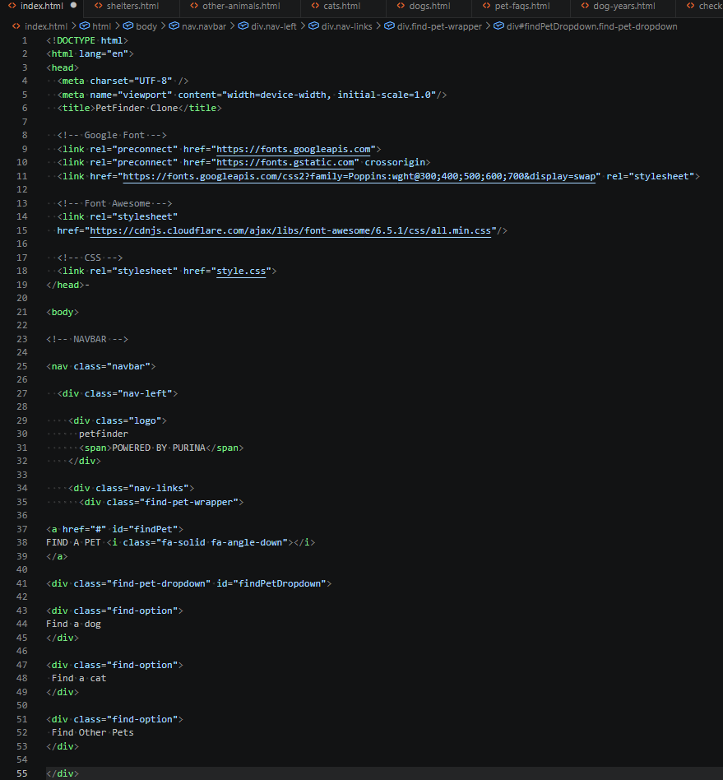
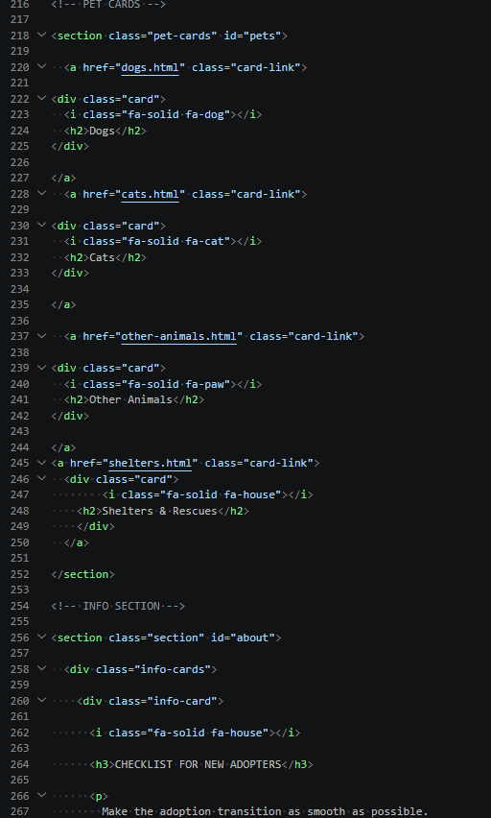
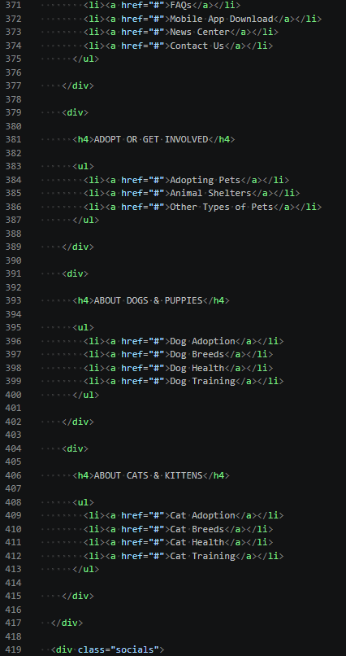
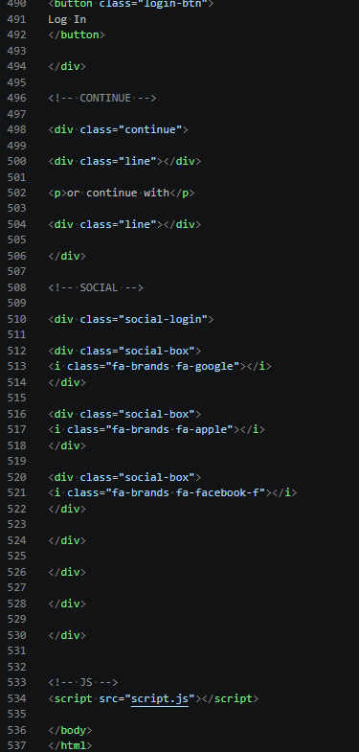

- Home Page

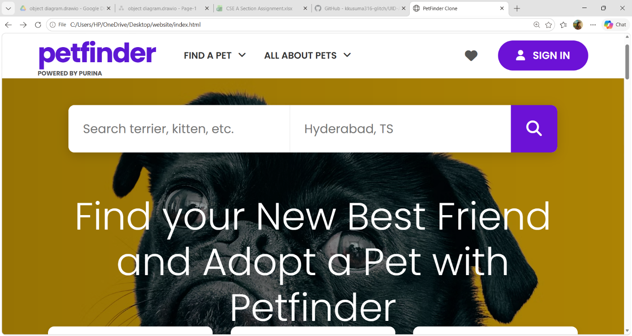
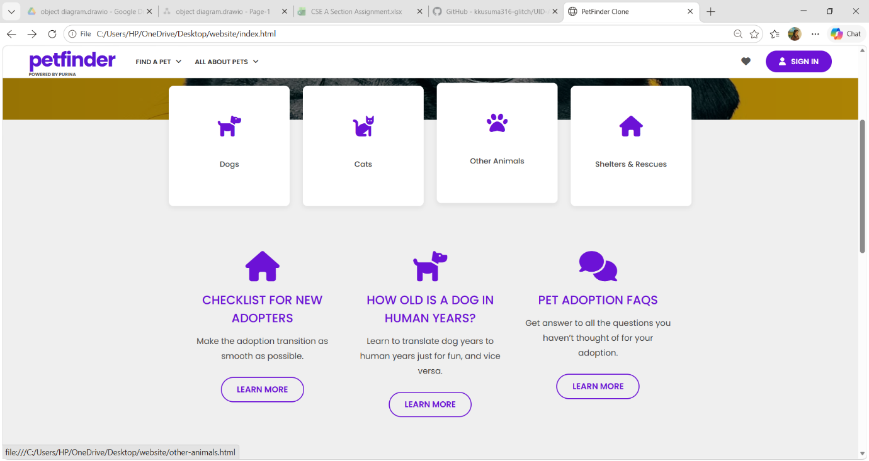
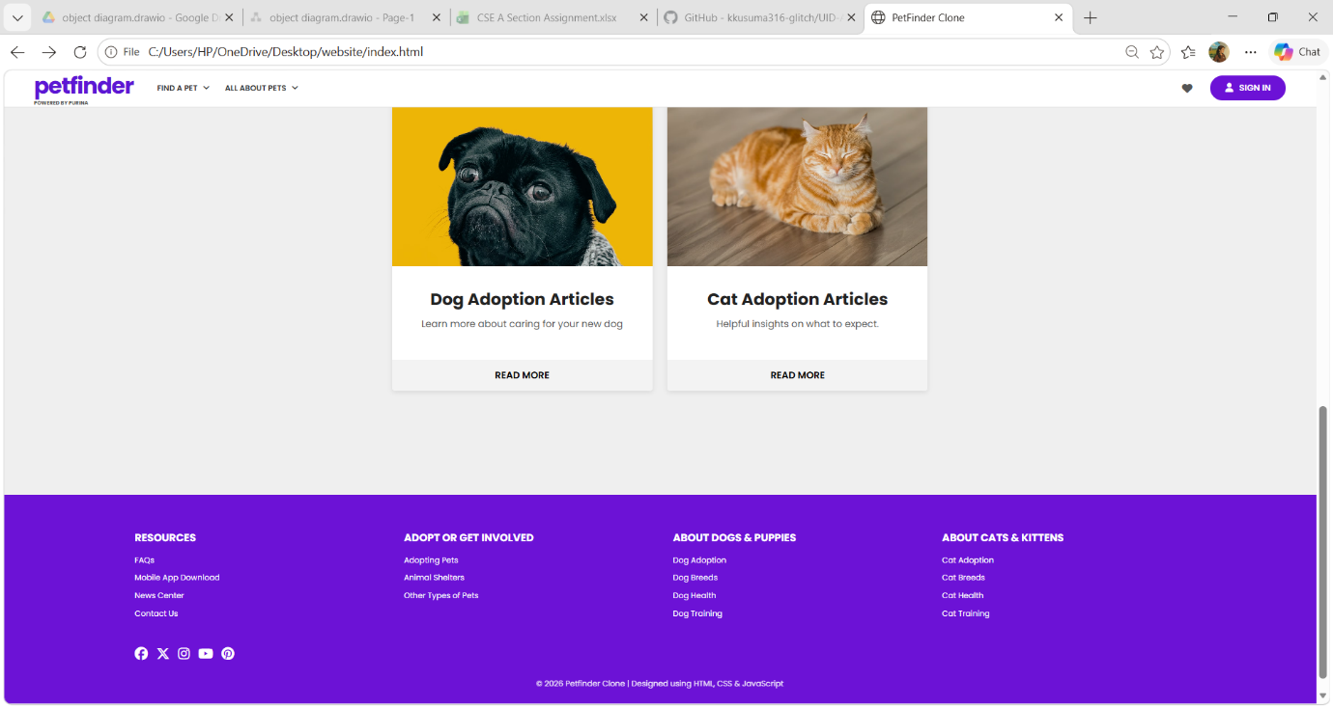

- Find a Pet dropdown
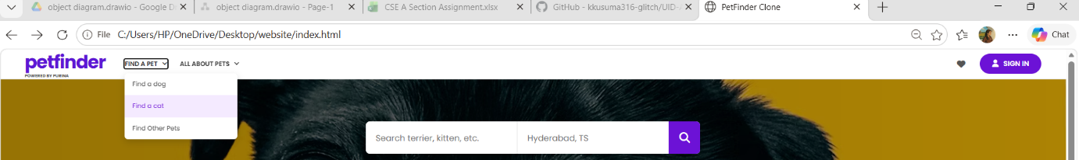
- All About Pets dropdown

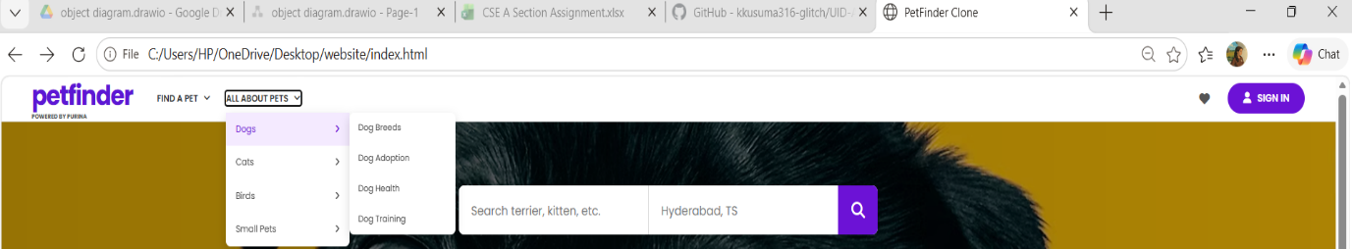

- Search functionality

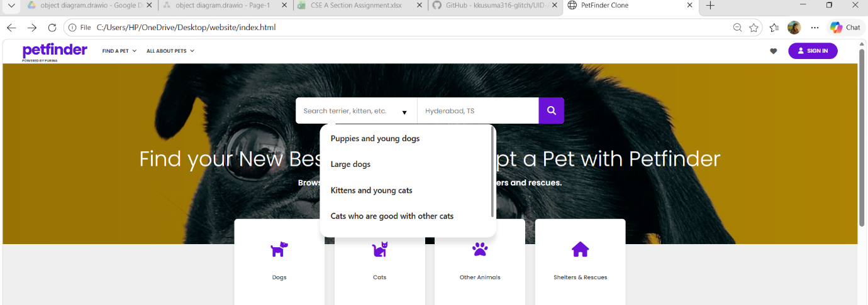

- SIGN IN Button
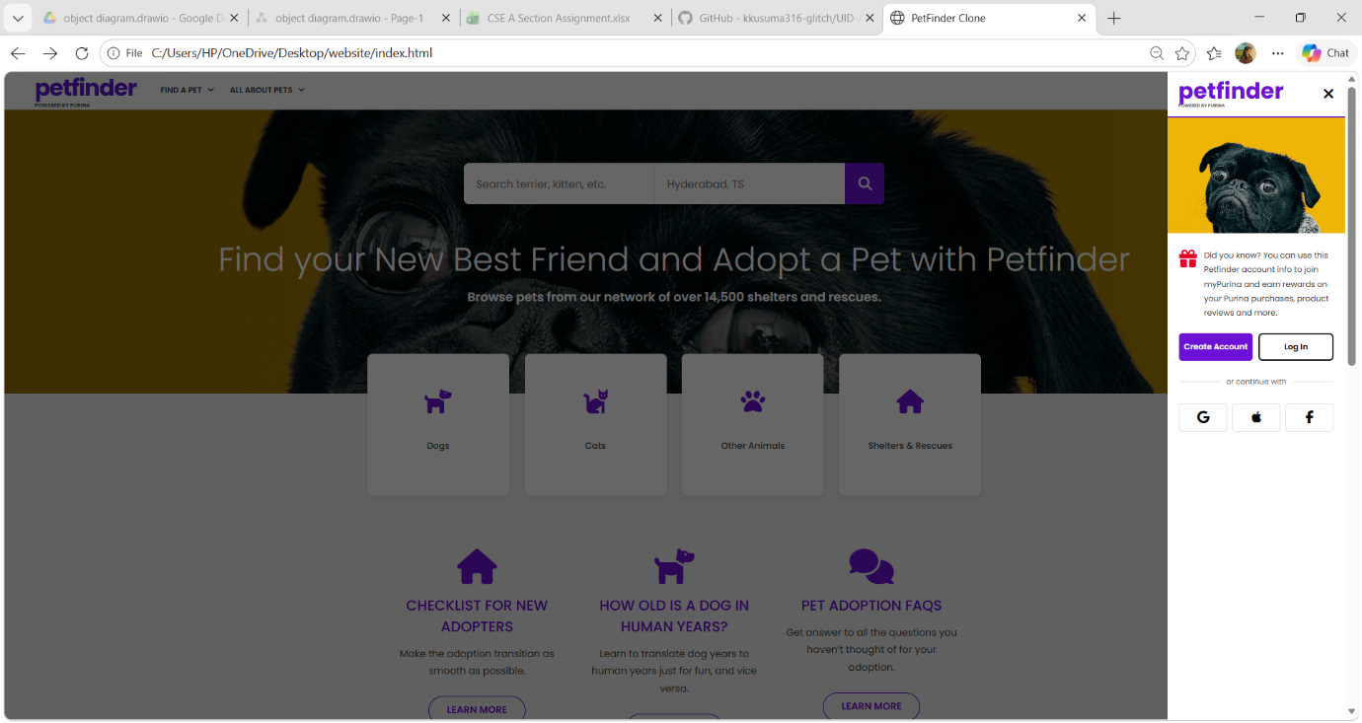

Dogs Module
The Dogs page displays adoptable dogs with:
- Search box
- Filter options
- Dog cards
- Breed information
- Adoption options
- Sorting features
Code
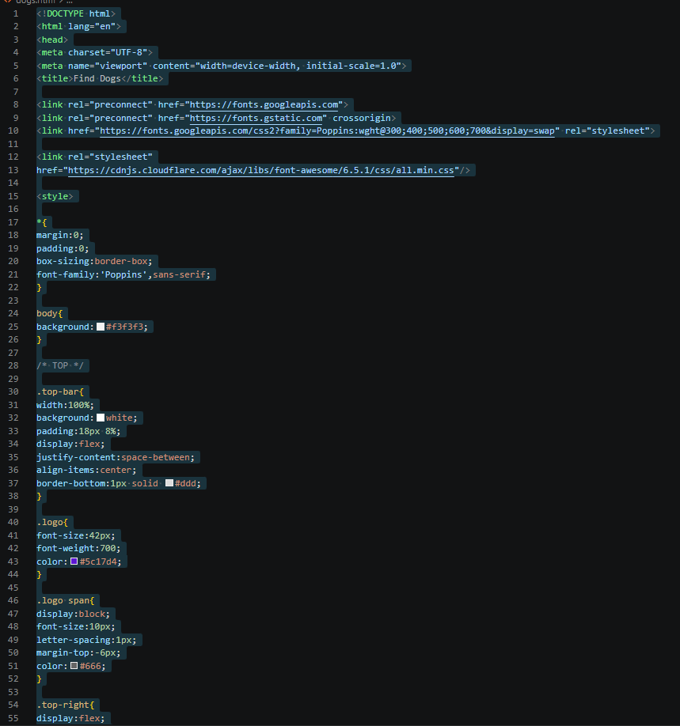
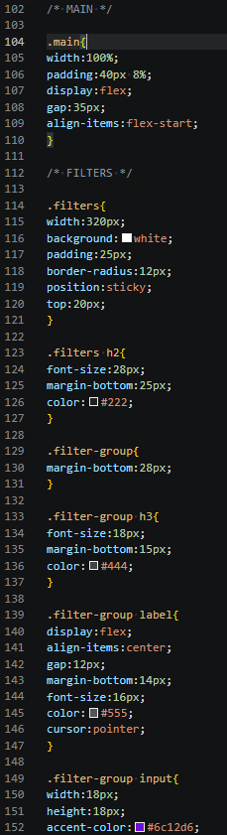
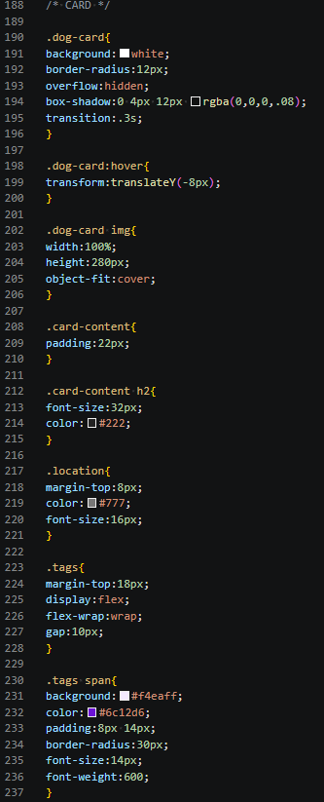

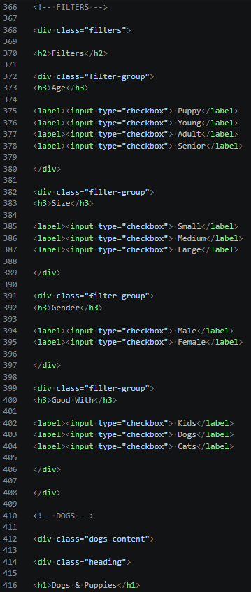
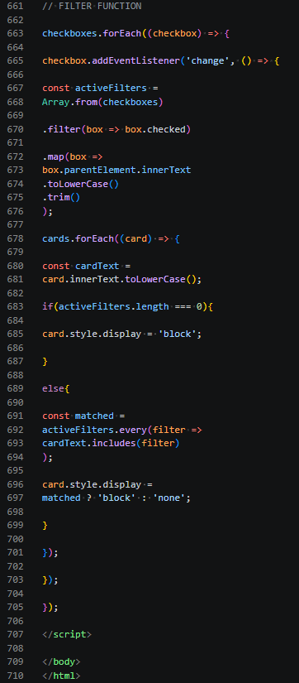

Output
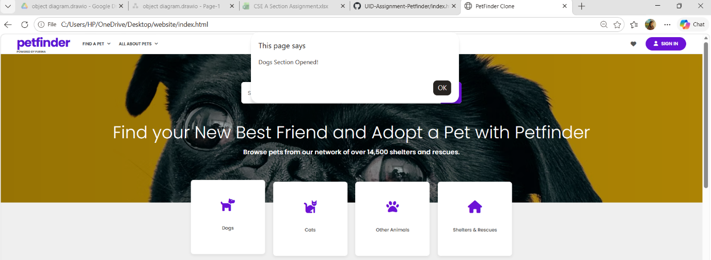

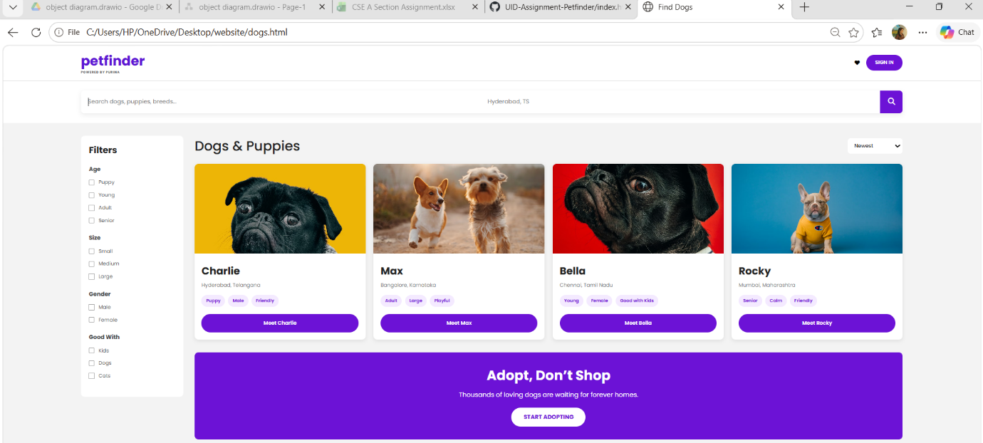
Cats Module
The Cats page provides:
- Search functionality
- Category filters
- Cat listings
- Adoption information
- Responsive pet cards
Code
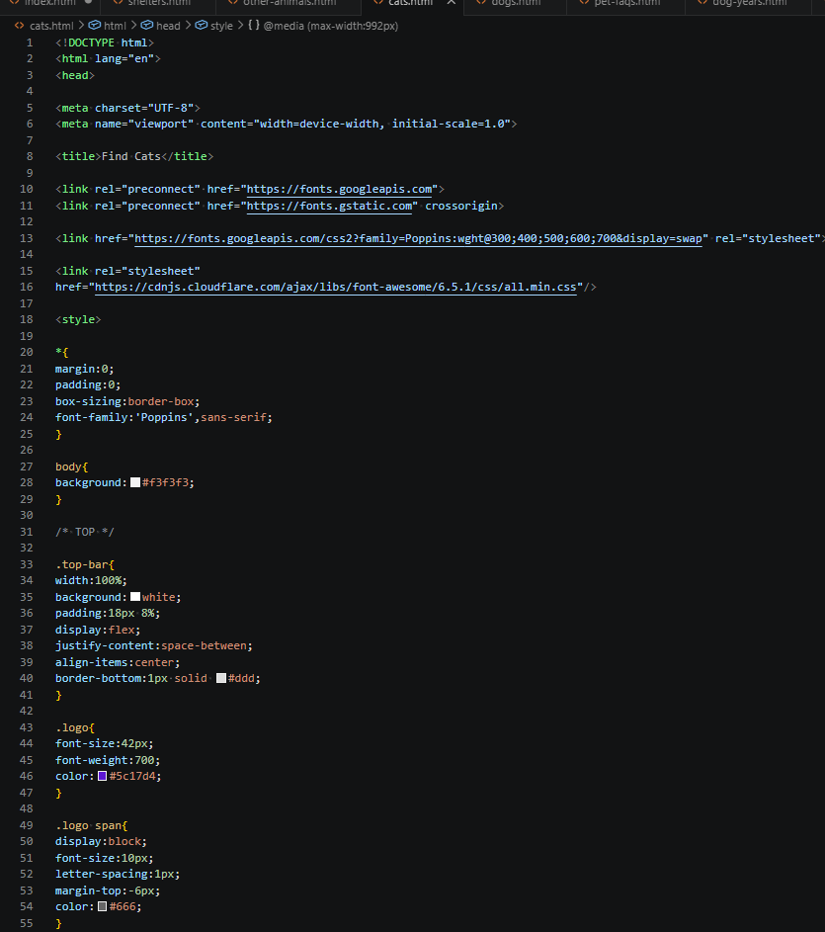
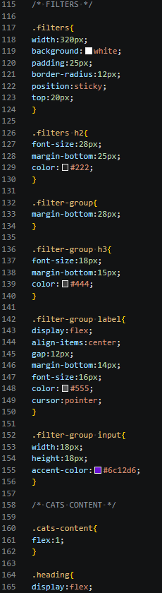
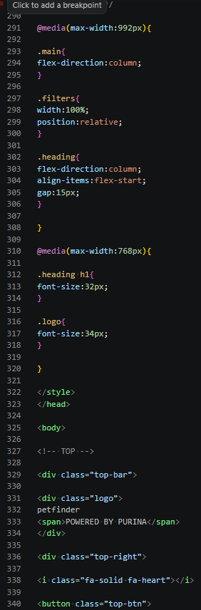
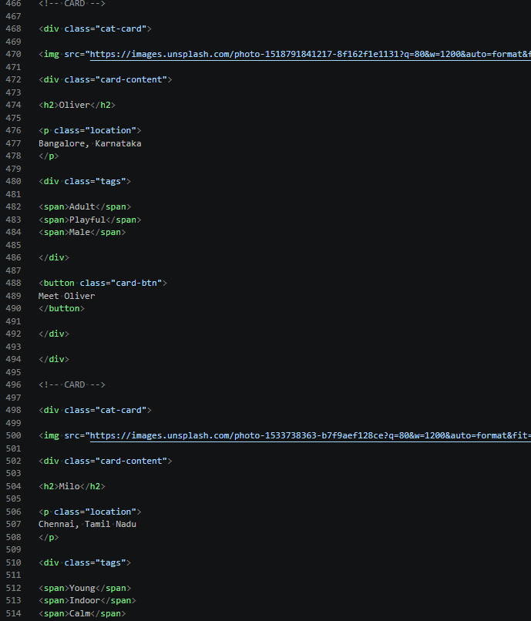
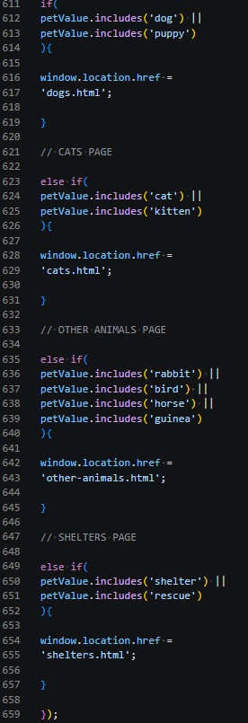
Output
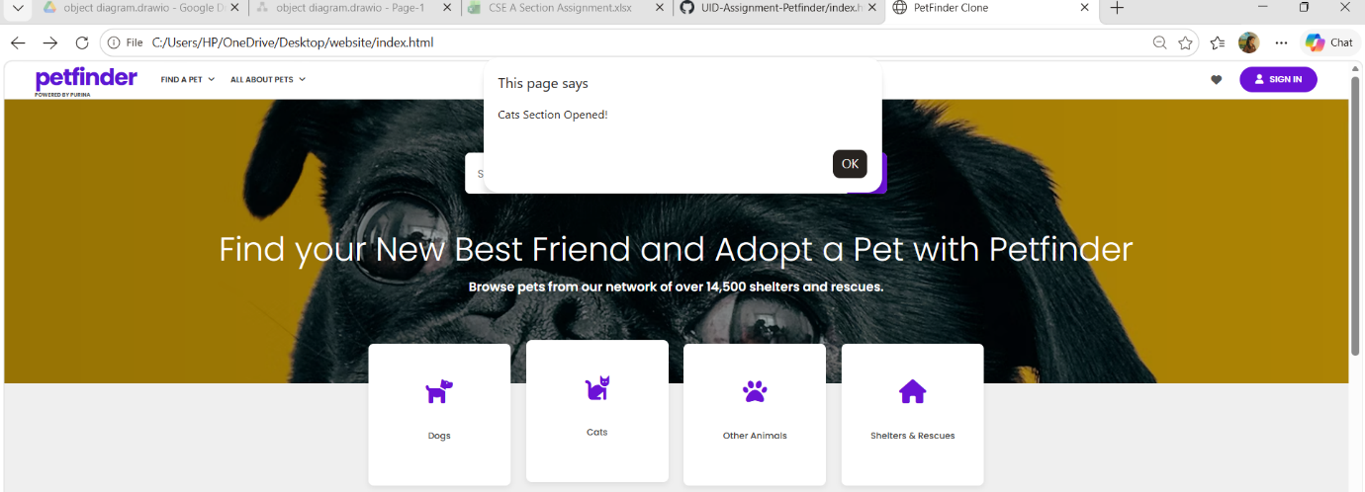
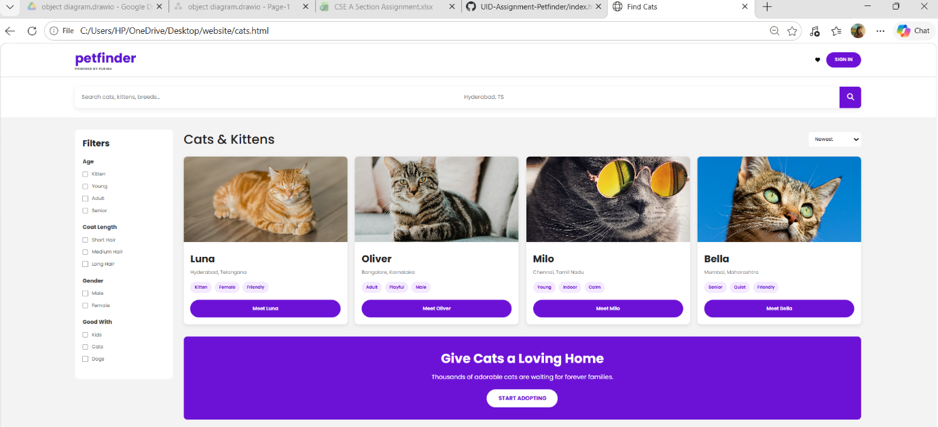

Other Animals Module
This section contains information regarding:
- Rabbits
- Birds
- Horses
- Guinea Pigs
Code
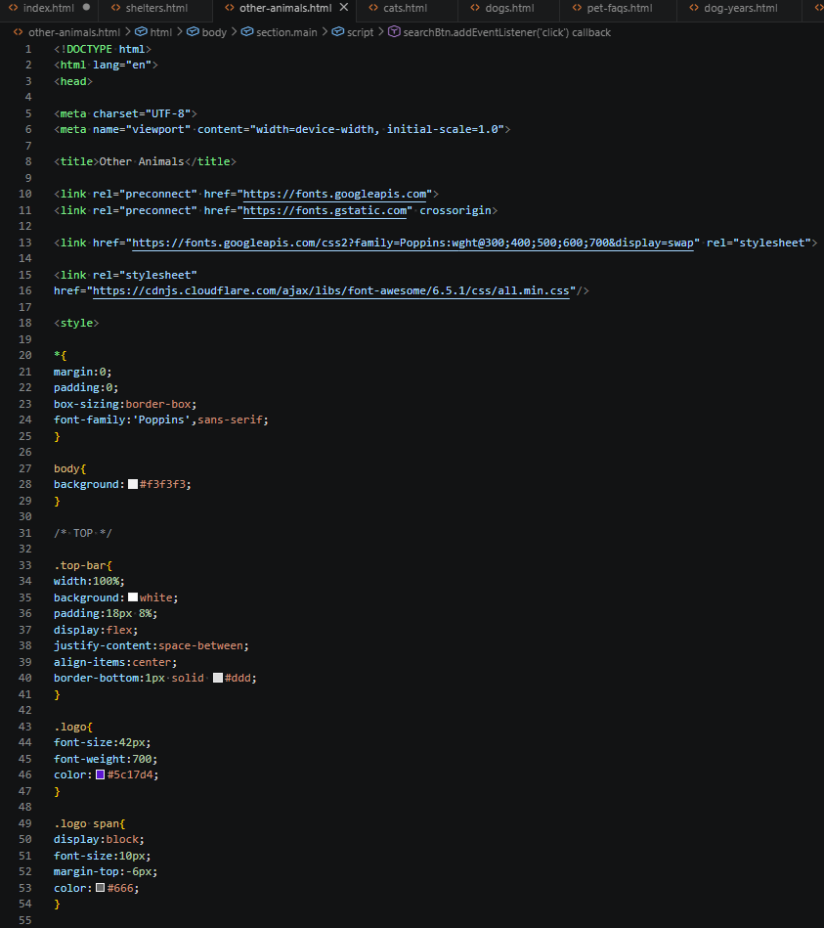
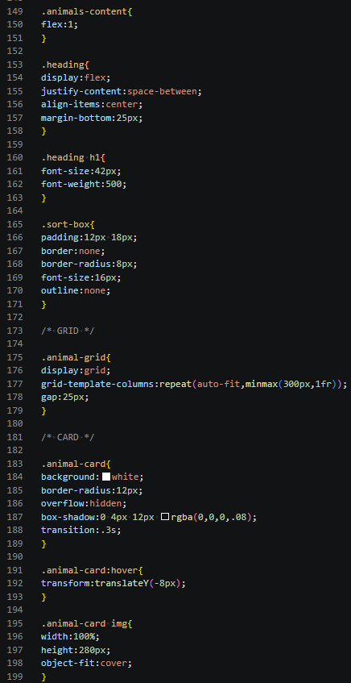
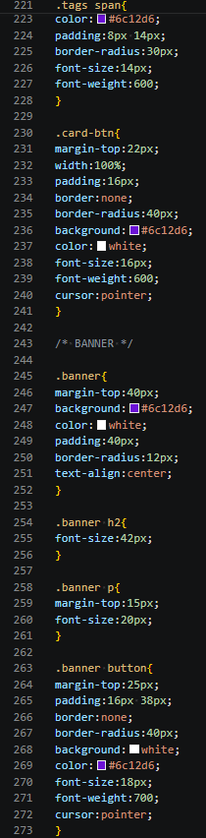
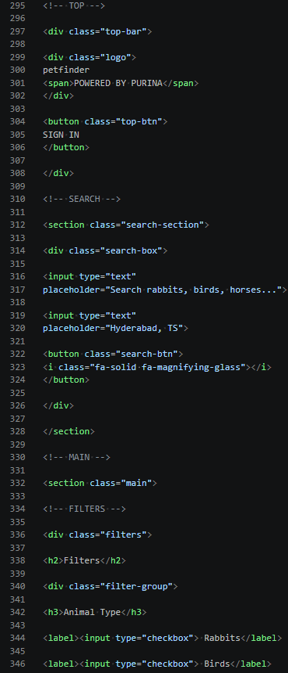
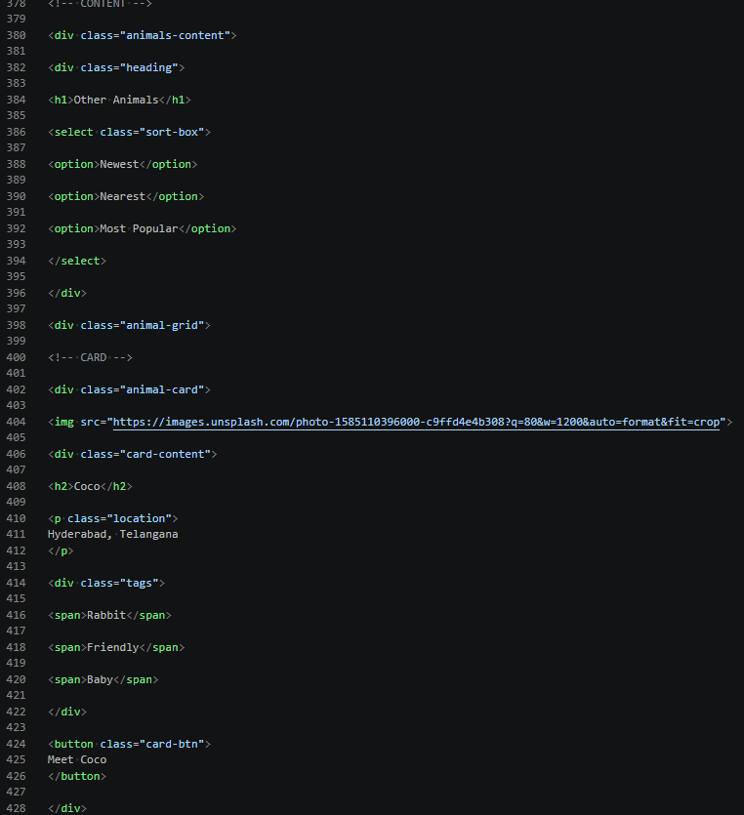

Output

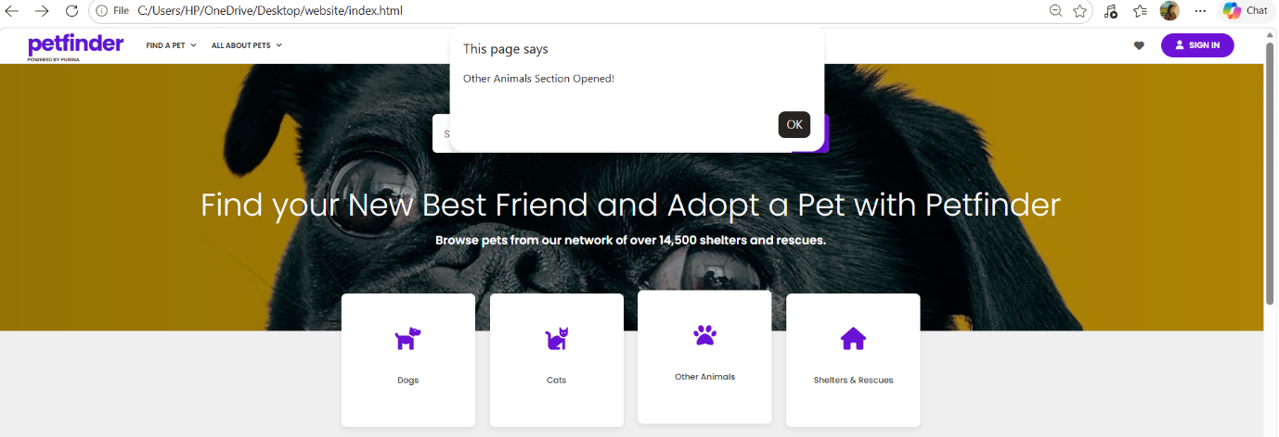
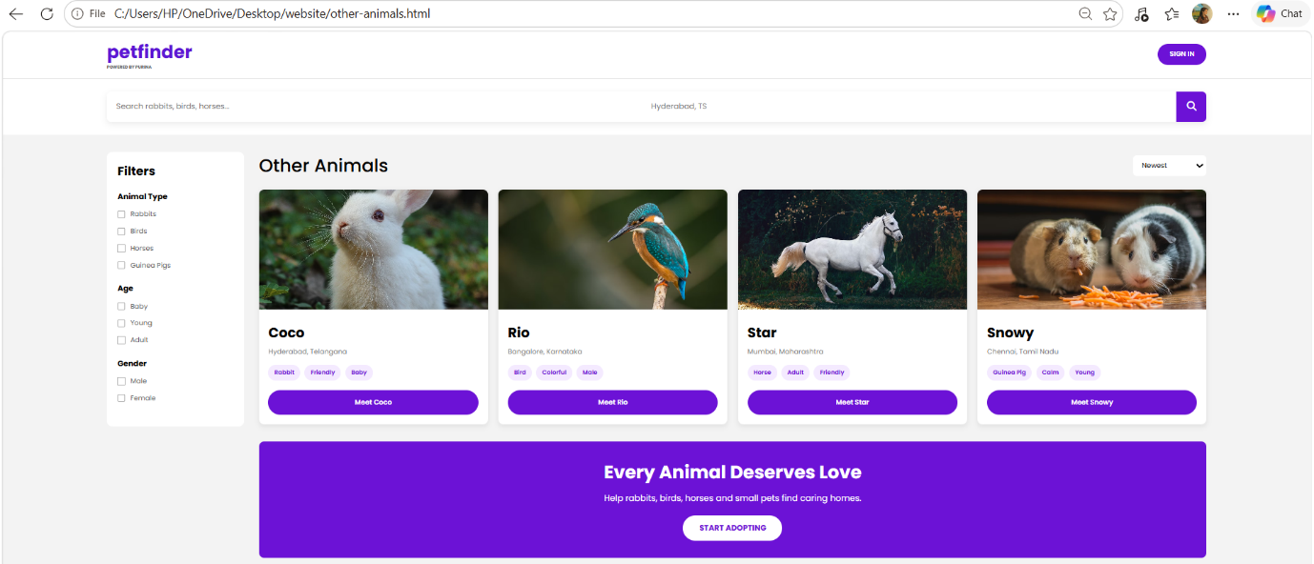

Shelters and Rescues Module
This page provides:
- Shelter listings
- Rescue organizations
- Location information
- Organization categories
- Search and filtering options
Code
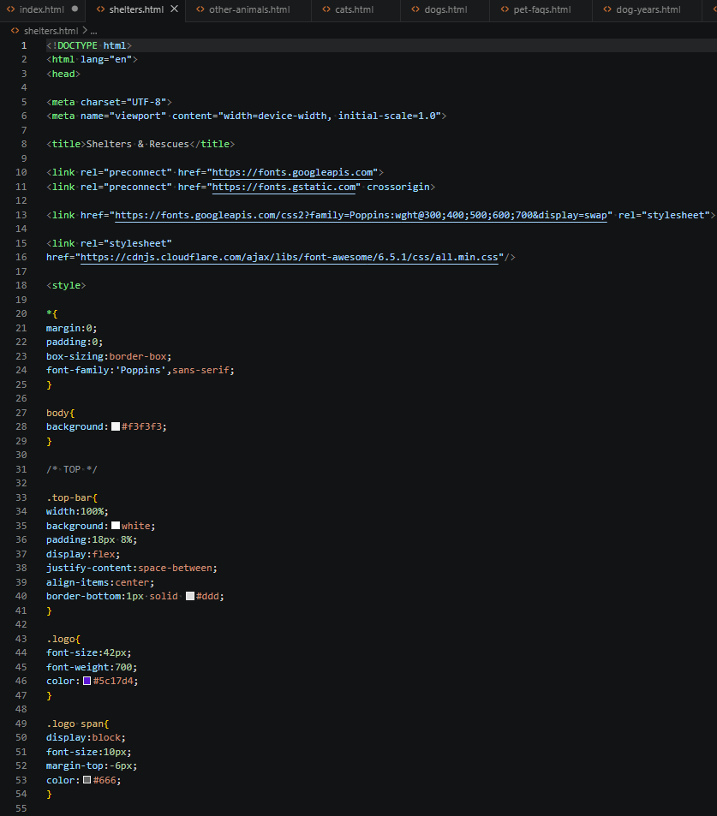
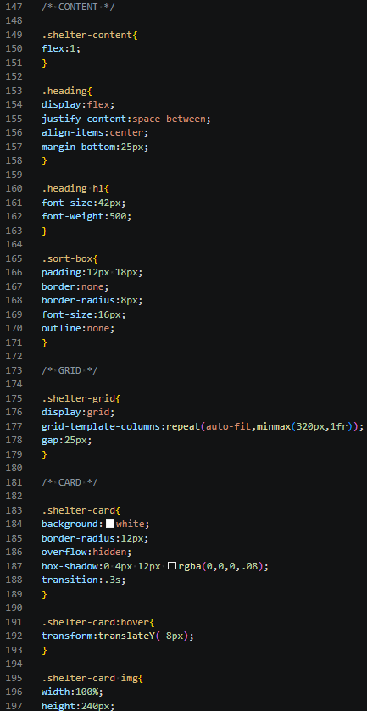
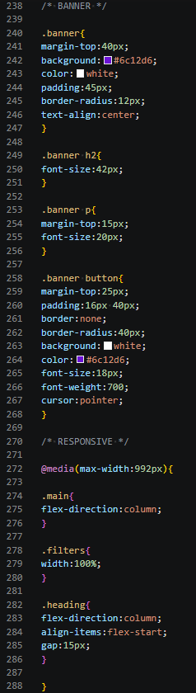
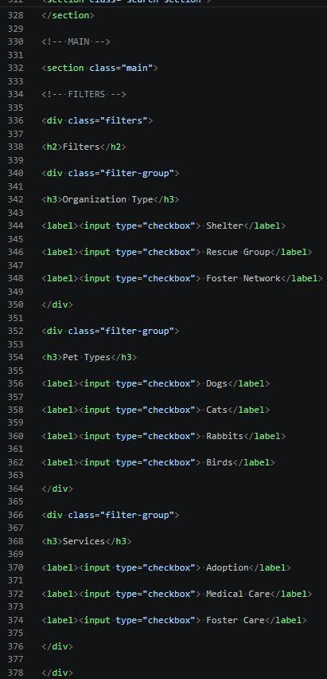
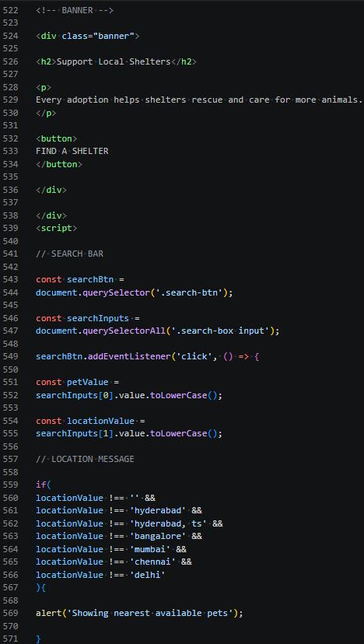
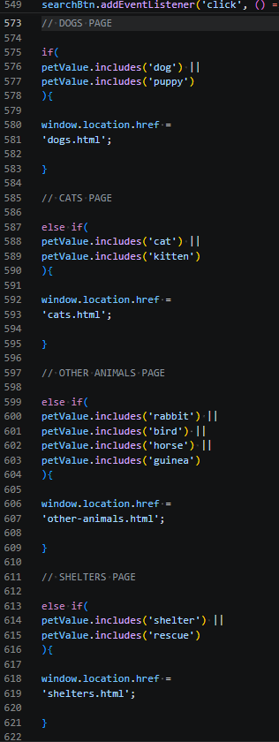
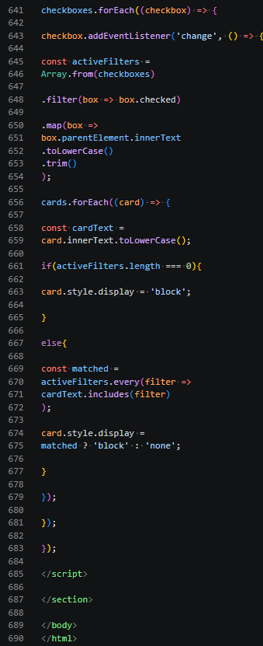
Output
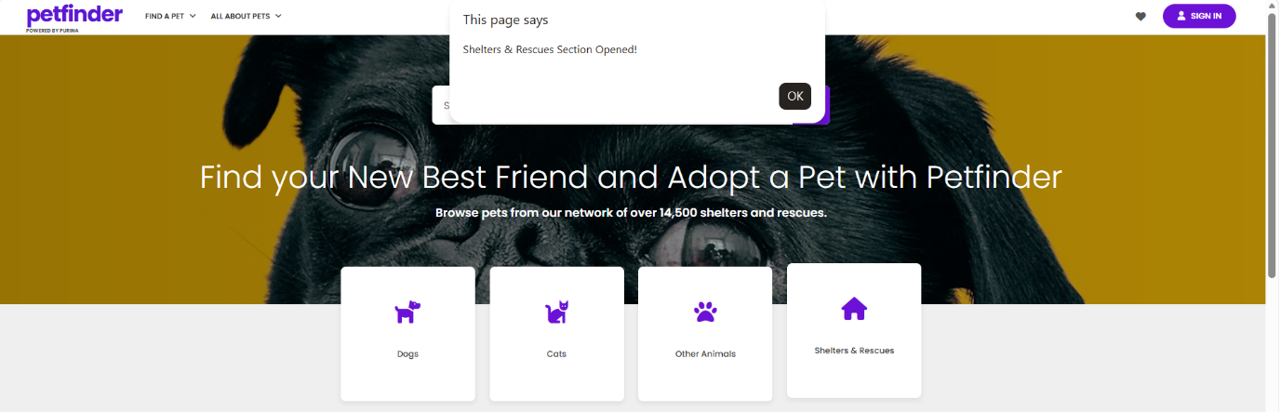
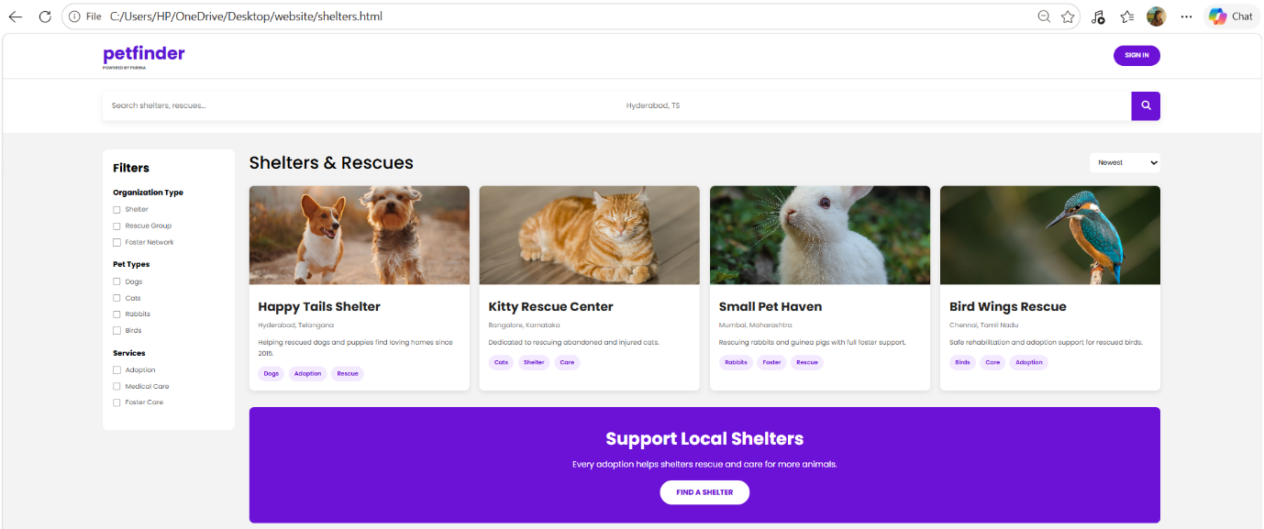

Pet Adoption Checklist Module
This section provides guidelines for new pet adopters including:
- Preparation before adoption
- Essential pet supplies
- Home readiness
- Pet care planning
Code
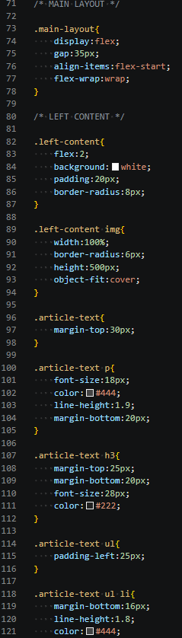
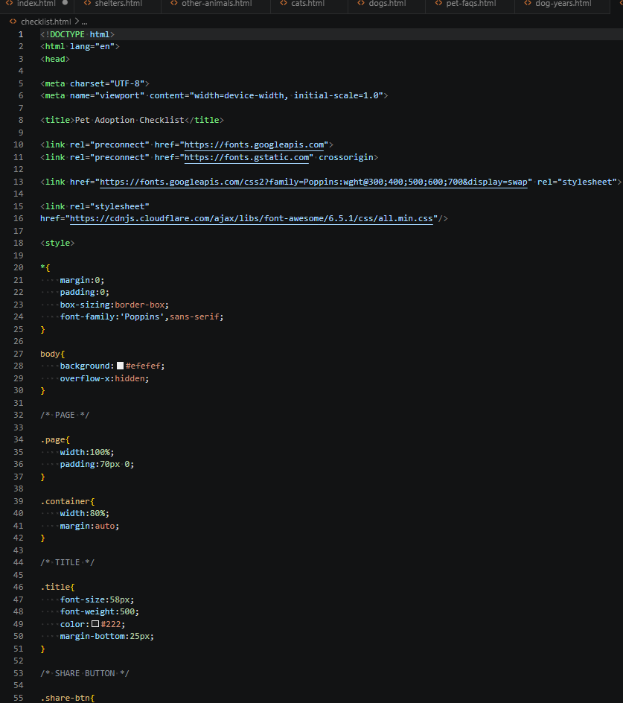
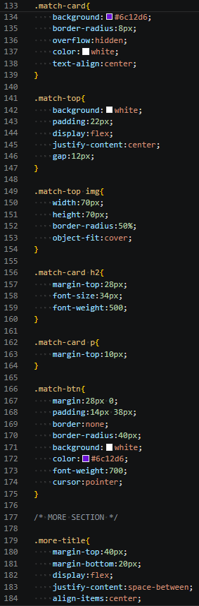

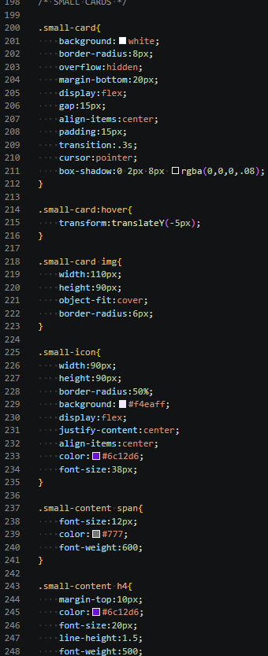
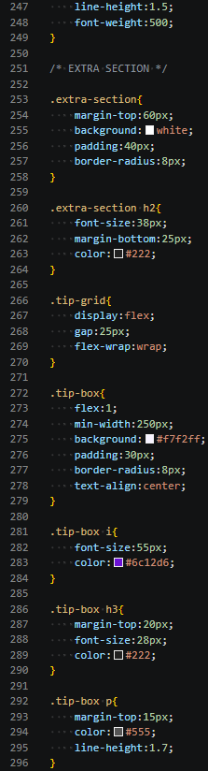
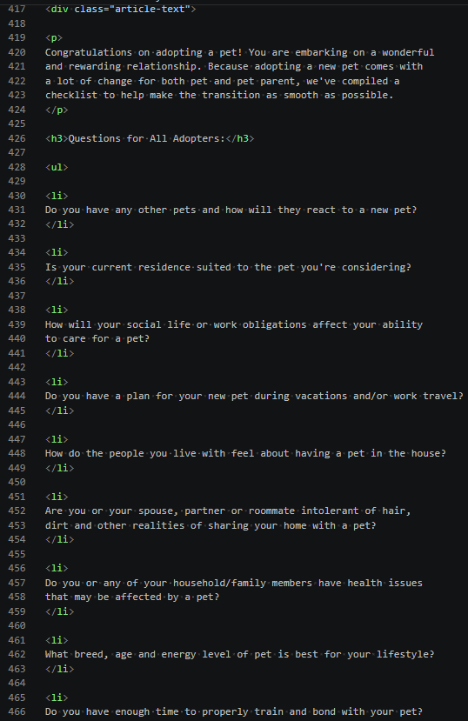
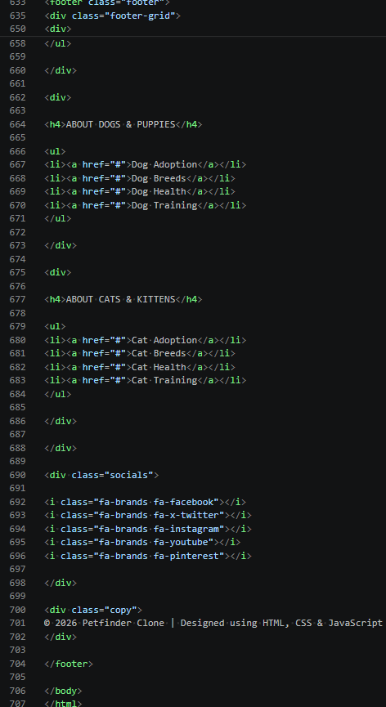
Output

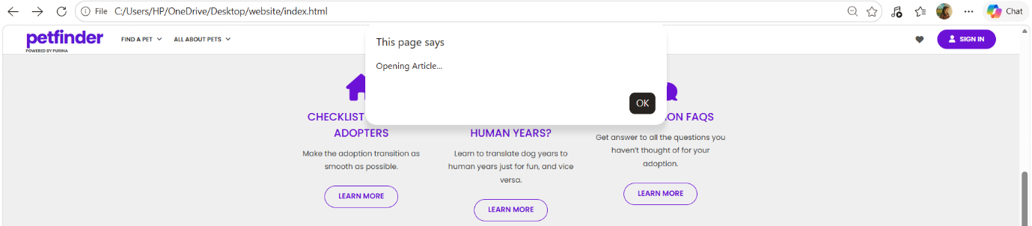

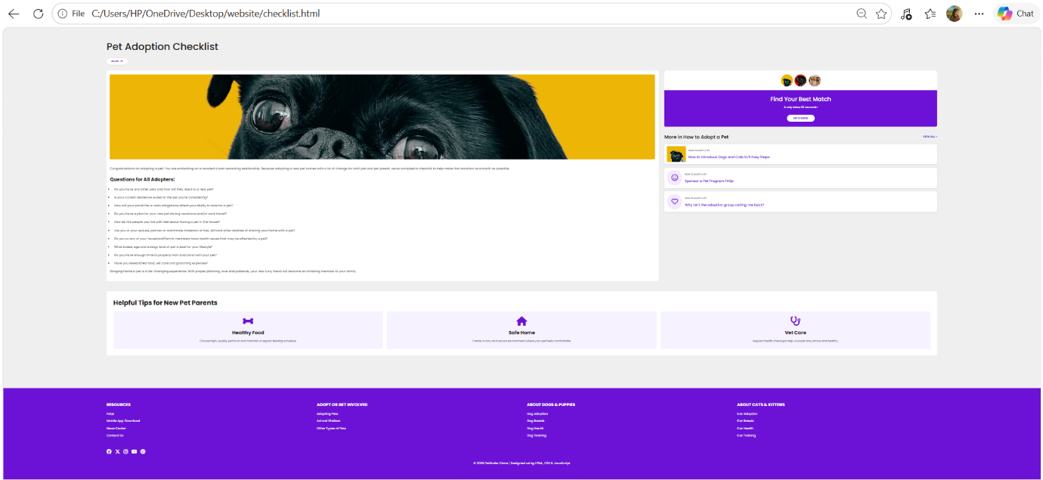

Dog Adoption Articles Module
This module contains educational articles about:
- Dog adoption process
- Puppy care
- Adoption tips
- Responsible pet ownership
Code
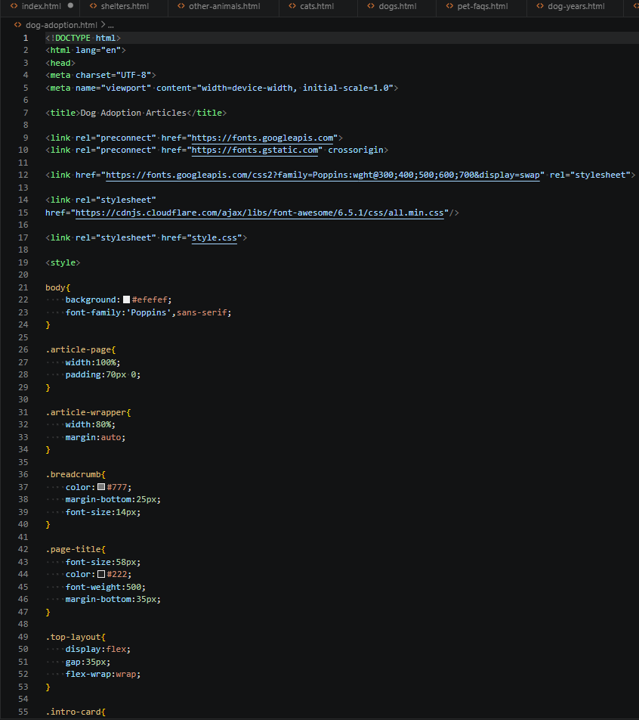
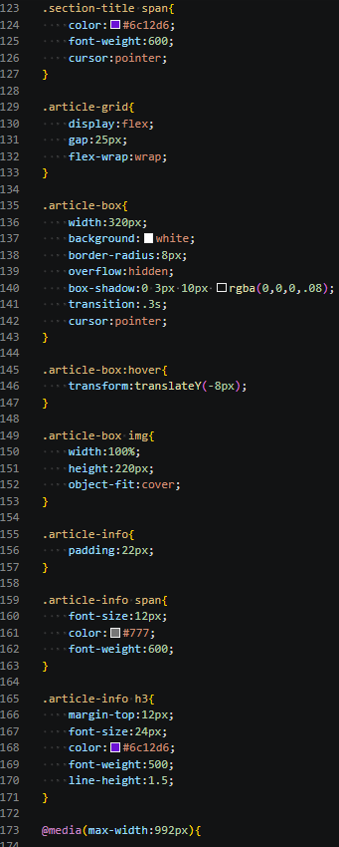
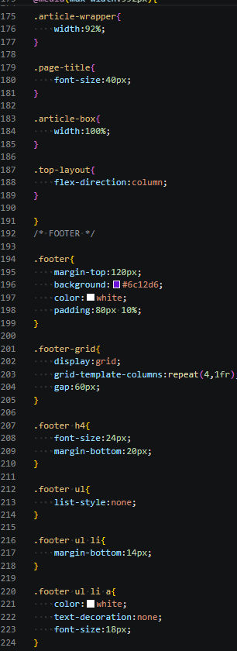
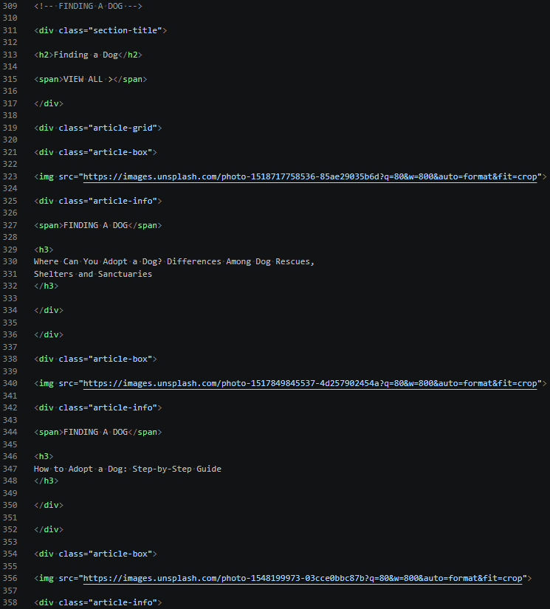
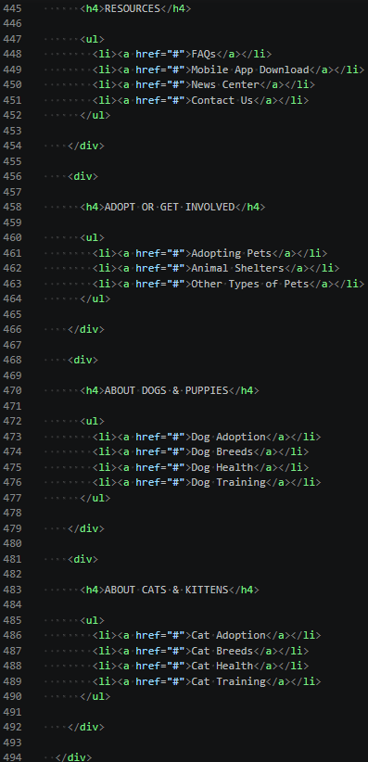
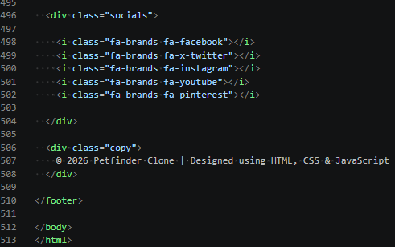
Output
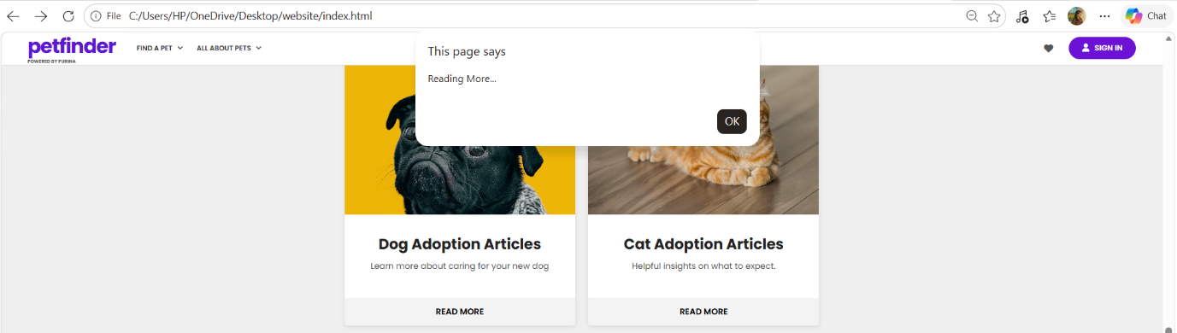
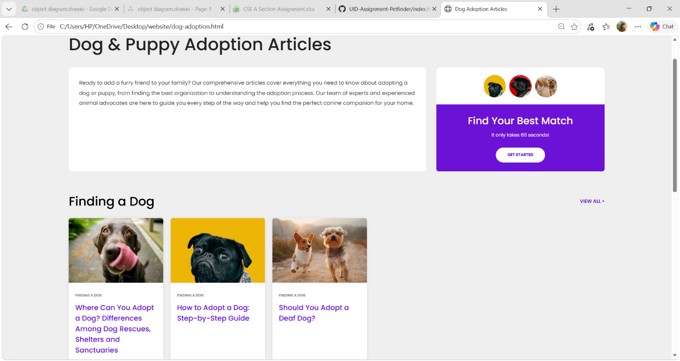
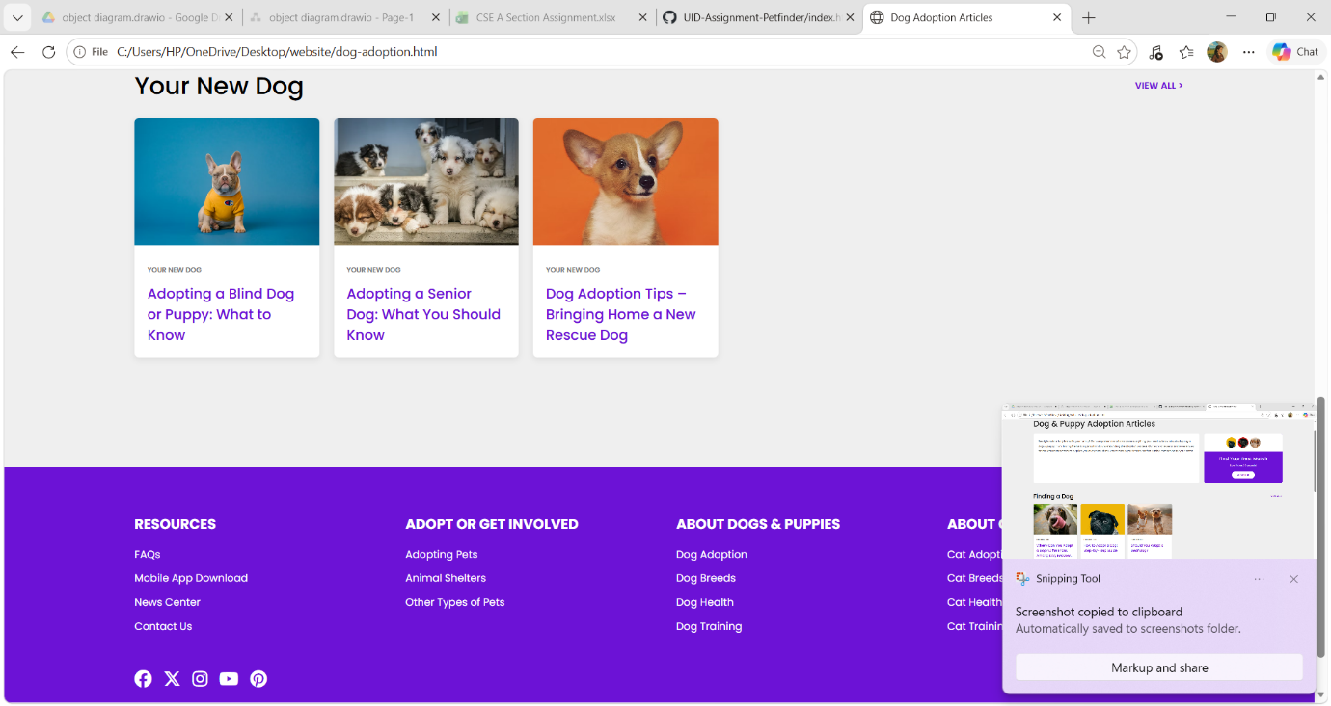

Cat Adoption Articles Module
This section provides:
- Cat adoption guidance
- Kitten care information
- Adoption recommendations
- Pet care articles
Code
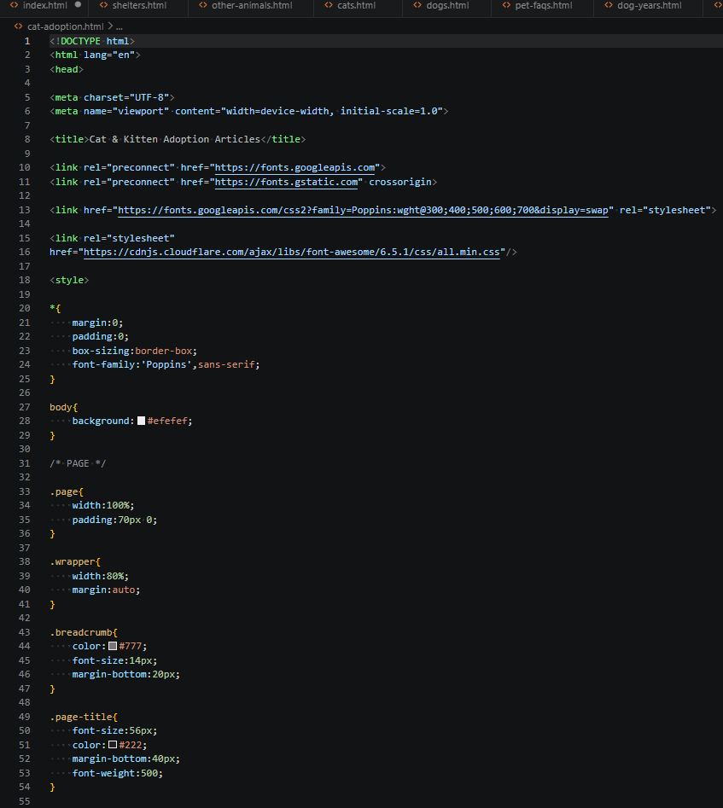

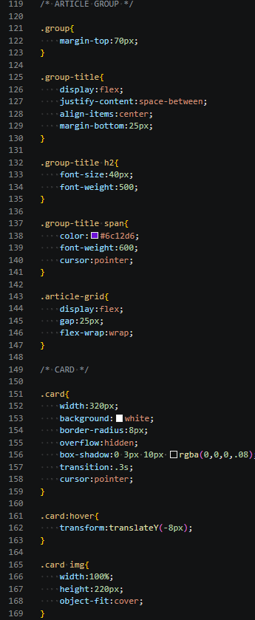
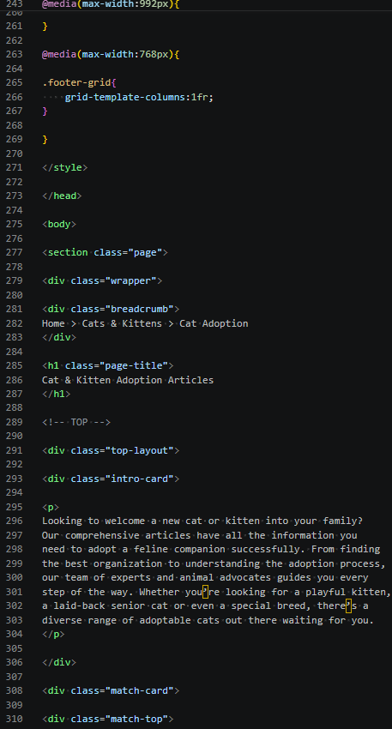
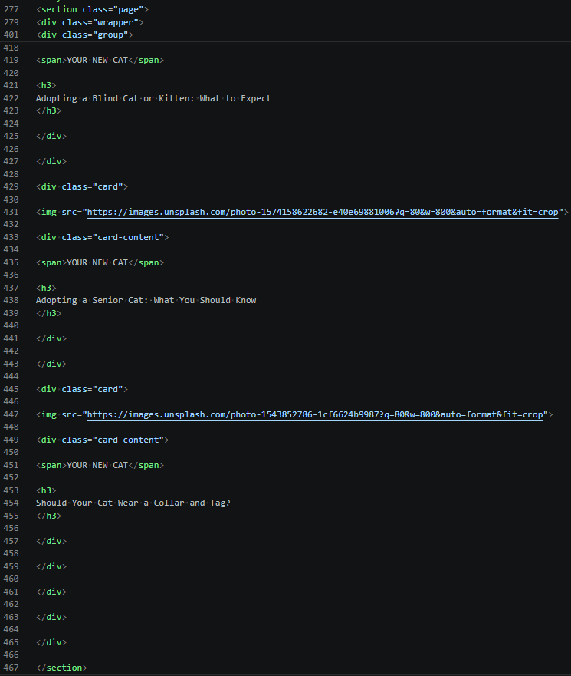
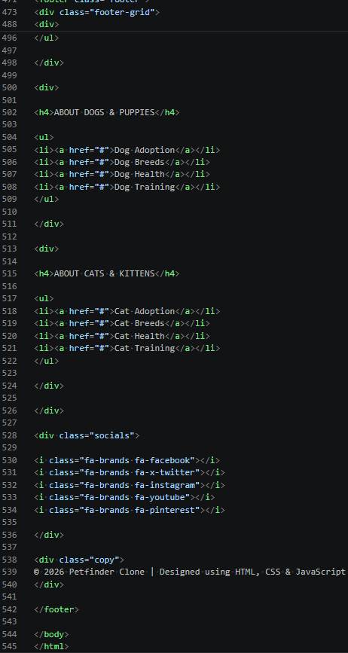
Output

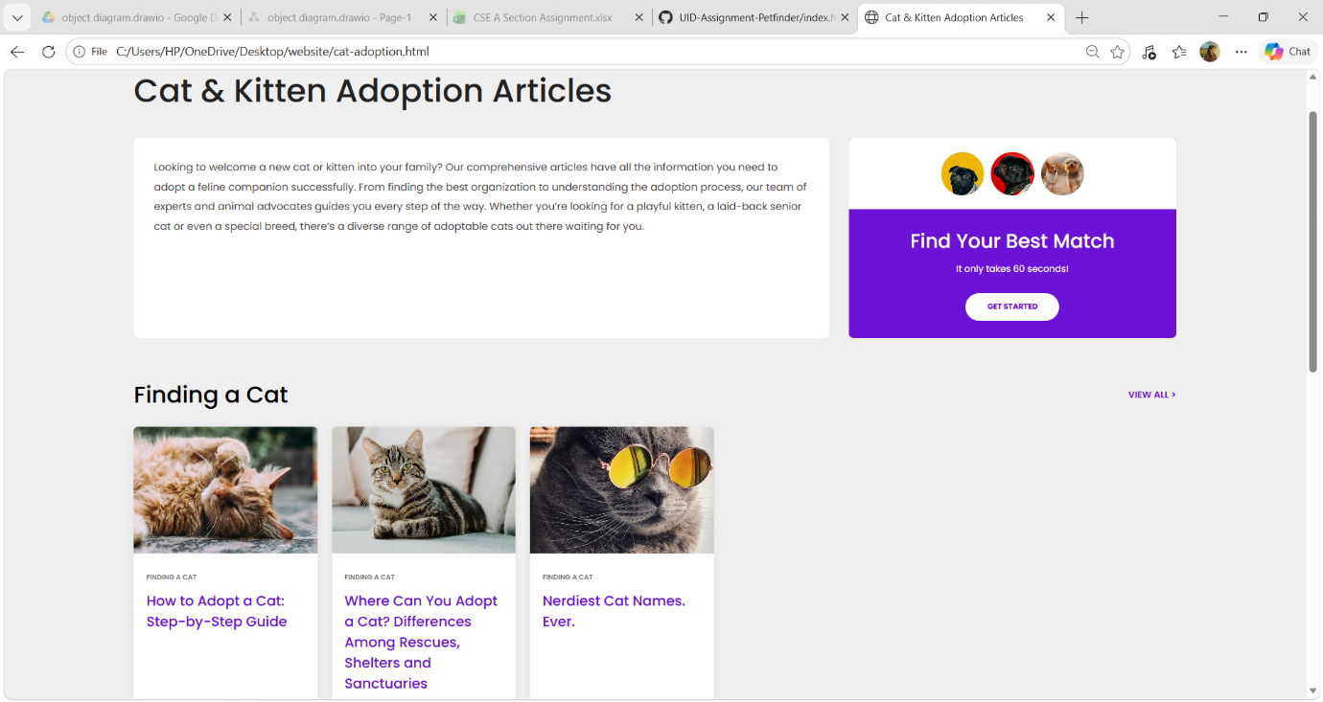
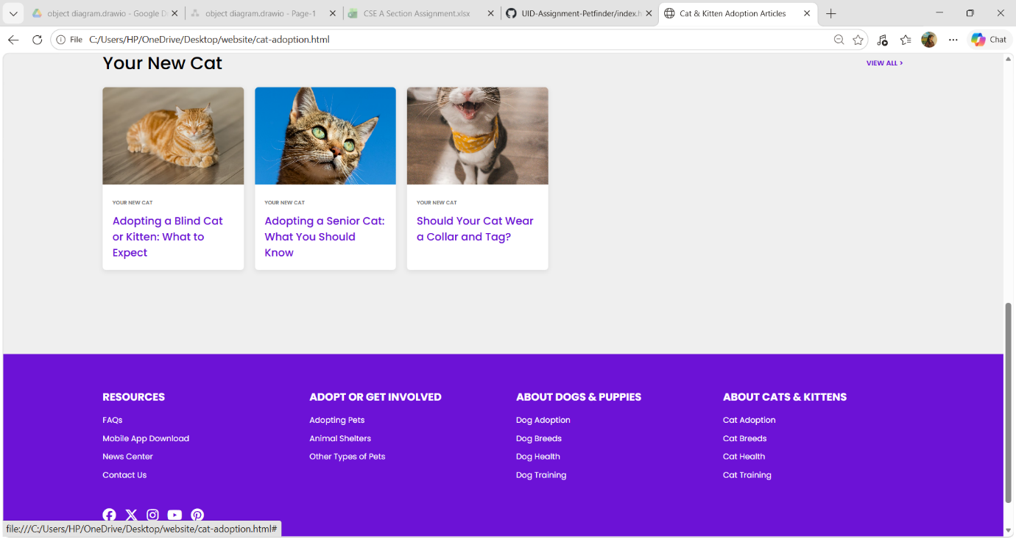

Dog Years Information Module
This educational page explains:
- Dog age conversion
- Human year comparison
- Dog life stages
- Fun pet facts
Code
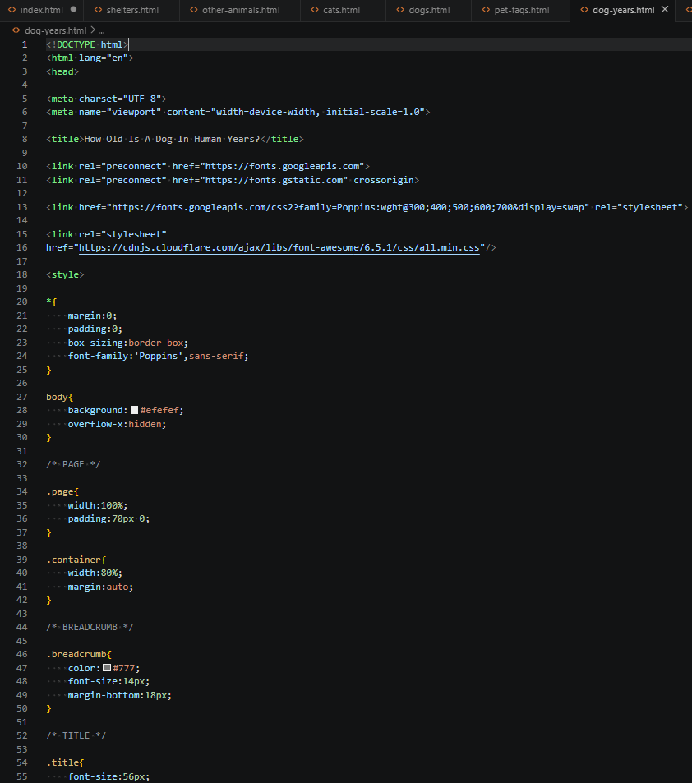
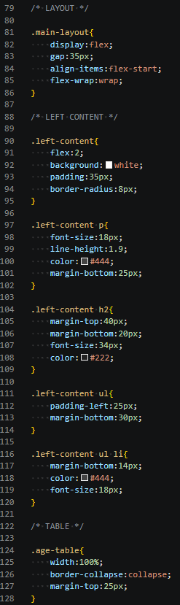
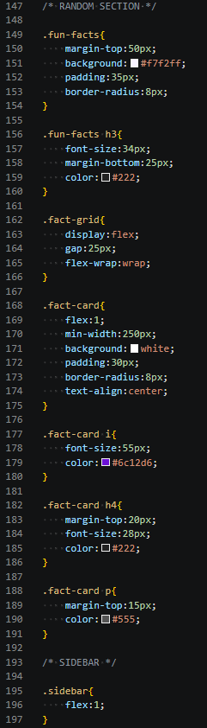
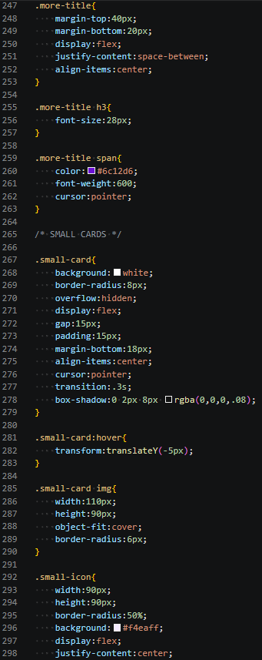
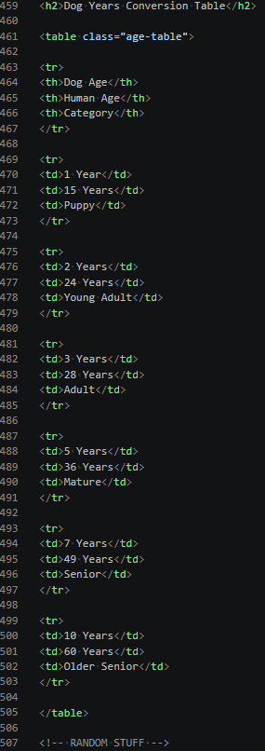

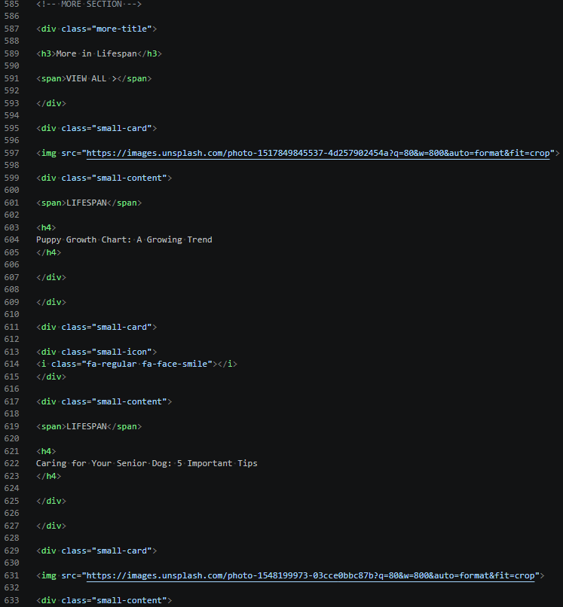
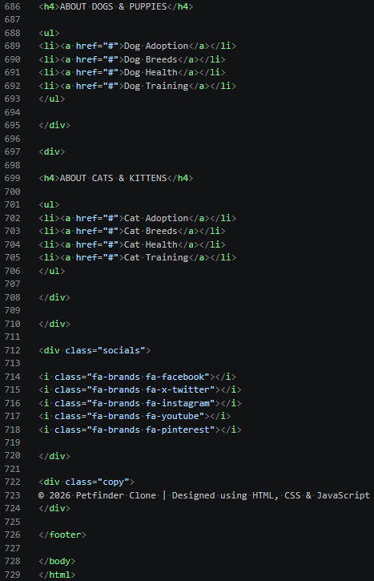

Output


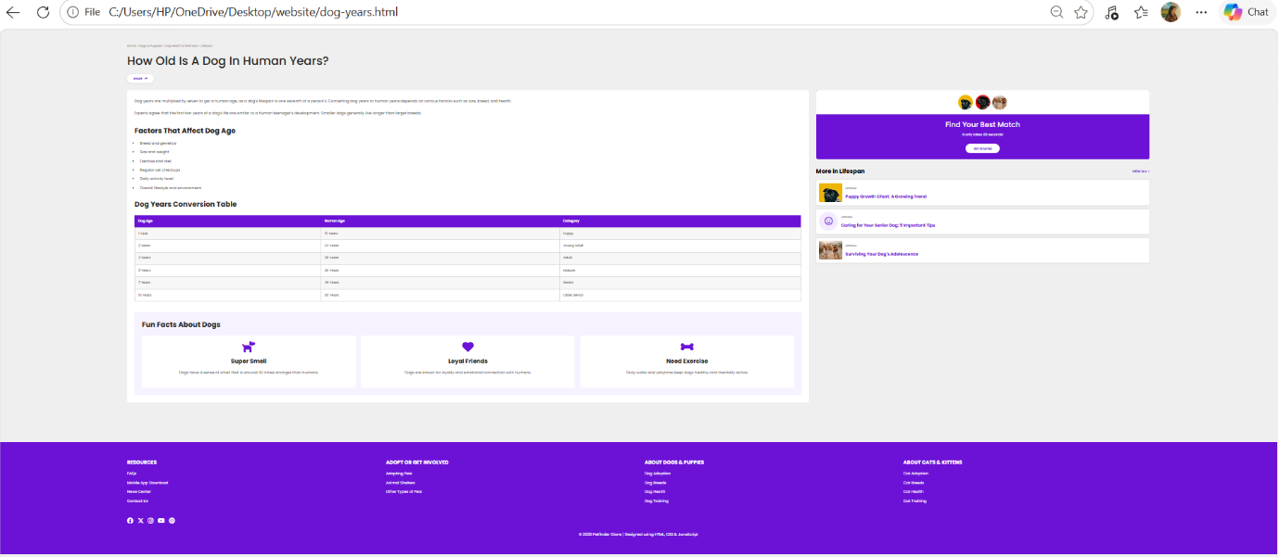

Frequently Asked Questions Module
This page contains:
- Common adoption questions
- Adoption procedures
- Pet care guidance
- Helpful resources
Code
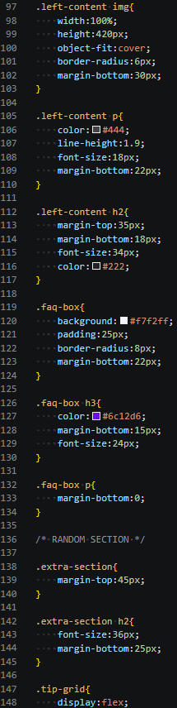
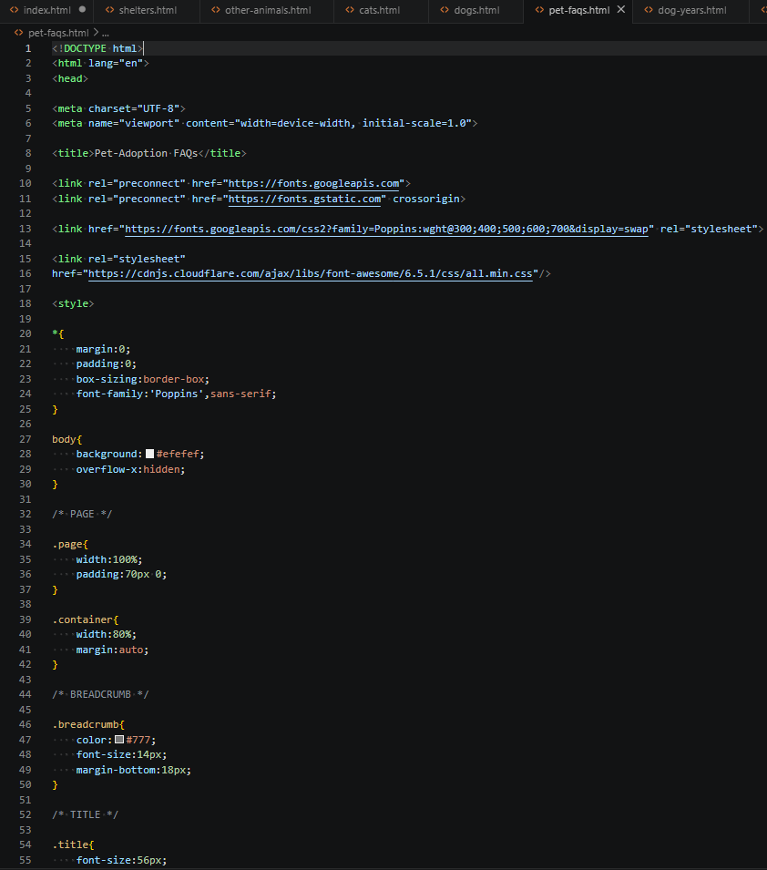
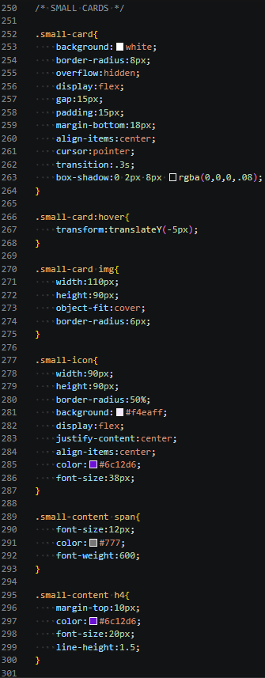

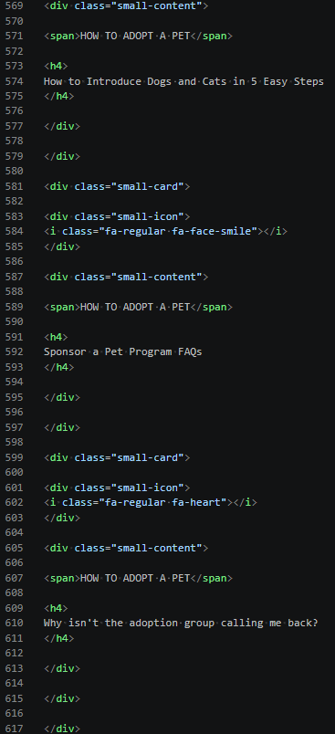
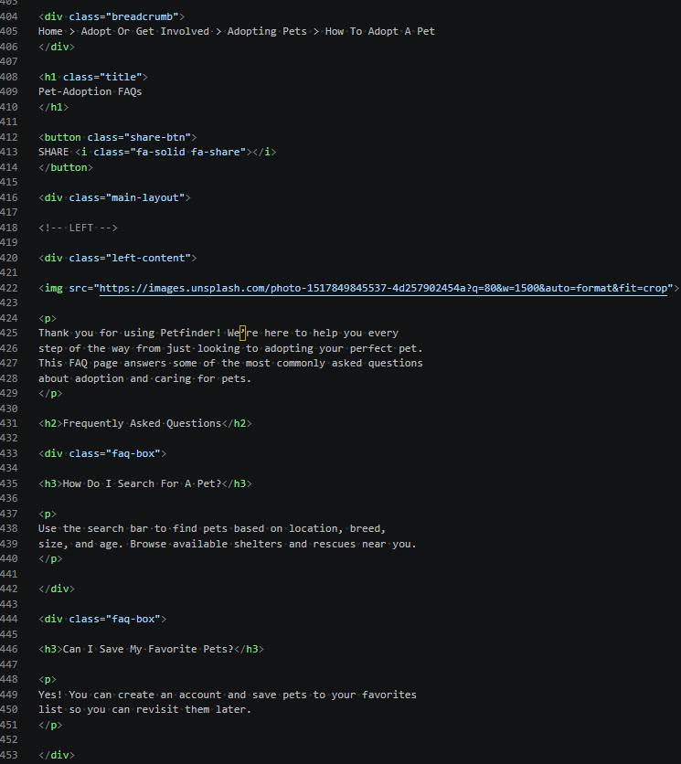
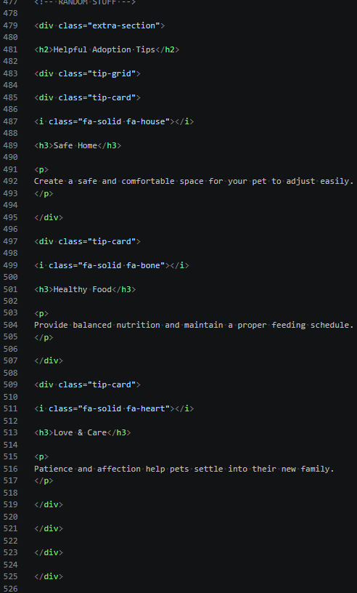
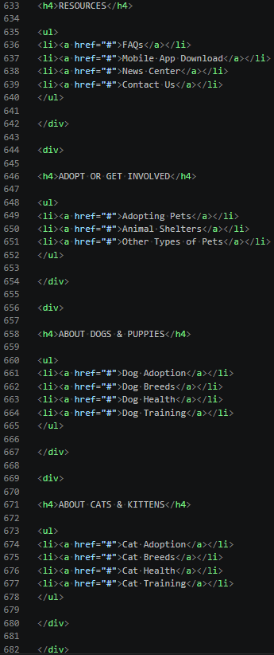
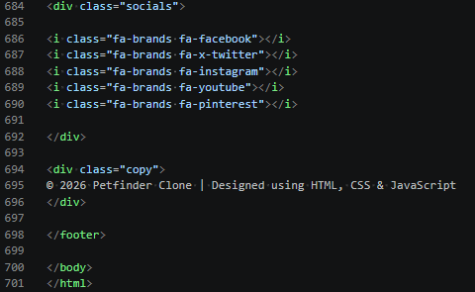
Output

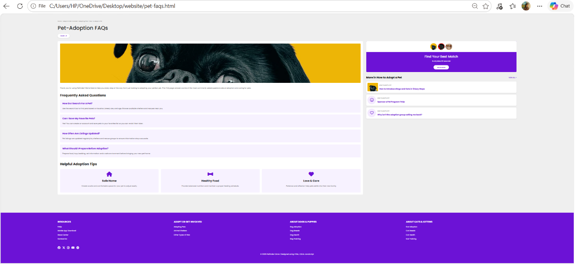

FEATURES IMPLEMENTED
Search Functionality
Users can search for pets using keywords such as dogs, cats, puppies, kittens, shelters, rabbits, and birds. Based on the entered keyword, the user is redirected to the appropriate page.
Dropdown Navigation
The website includes:
- Find a Pet dropdown
- All About Pets dropdown
- Category navigation menus
Interactive Elements
- Search buttons
- Hover effects
- Alert notifications
- Dynamic menus
- Navigation controls
CHALLENGES FACED
- Creating responsive layouts.
- Managing multiple interconnected HTML pages.
- Implementing search-based page navigation.
- Designing consistent UI across all modules.
- Handling dropdown menu interactions using JavaScript.

CONCLUSION
The Pet Finder Website successfully implements a modern front-end solution for pet adoption and pet information management. The project combines multiple interconnected modules including pet listings, educational resources, shelters and rescues, adoption guides, and FAQs. Through the use of HTML, CSS, and JavaScript, a responsive and user-friendly platform has been developed that enhances the experience of users searching for pets and adoption-related information.

